**Android Development: Project 1 (Option 2: Event-Tracking Application)**

**EventzGeo**

Matt Knutson

Online Student, Southern New Hampshire University

CS-360: Mobile Architecture & Programming

Instructor Walker

July 21st, 2024

This project will utilize an Event-Tracking application template and the name of the application will be EventzGeo. The goal of the application will be to help users find local activities based on their current location, and/or location preferences. The app will host a unique selection of “Event Types”, providing the user with resources that will enable them to explore their current location and network with local residents. These “Event Types” will be based on four main criteria. Each of these criteria will contain subcategories to hold local events, and each subcategory will represent an “Event Type”.

The four main categories of “Event Types” are:

* Entertainment
* Educational
* Community
* Athletic

An example of subcategories, or “Event Types”, are:

* **Entertainment**
  + Local Music & Music Festivals
  + Game Rooms (i.e. Arcades, Escape Rooms, Trampoline Parks, etc…)
  + Movies Theaters
  + Amusement Parks & Fairs
  + After Hours (i.e. Night Clubs, Raves, etc…)
* **Educational**
  + Live Workshops
  + Certificate Programs
  + Museum Exhibits
  + Local Tours
  + Zoo & Aquarium
* **Community**
  + Local Libraries
  + Art Festivals
  + Community Centers
  + Farmers Market
  + Job Fairs
* **Athletic**
  + Marathons
  + Sporting Competitions
  + Obstacle Racing
  + Wall Climbing
  + Hiking & Camping

This application is an Event-Tracking application, so by its very nature it is designed to track relevant events and scheduled dates for the user. The database will need to host multiple tables for storing app and user data. Here are the tables required:

* A table for the user’s name, password, & account information.
* A table to store events & their associated data.
* A table to store the user’s current location & location preferences.
* A table to store the user’s saved/upcoming plans. This table will be used as a reference to prioritize the order of upcoming events when they are listed on the main page.

The application will require a basic startup page to prompt the user for a username and password or allow the user to create a new account. Once logged in, the user will be brought to the main page where upcoming events will be displayed by a horizontally scrollable grid. By selecting an event, the user will be brought to an event summary page where they can purchase and add events to their plans. The user can delete planned events within the “Plans” tab by long pressing the event icon and selecting “Delete Event”. Above the main three tabs on the home page (“Upcoming”, “Locations”, “Plans”) will be two search bars that allow the user to search for either events or locations, or both at the same time. Once an event is added to a user’s “Plans”, the user will have the option to add the event to their preferred calendar app and phone notifications will be activated. The number of notifications and their frequency can be adjusted by the user in settings and can also be deactivated.

For this project, three user types have currently been identified:

* New Residents
* Travelers
* College Students

As a new resident, the user will have access to job fairs, city tours, local festivals, farmers markets, and other activities that will facilitate a unique experience in their new home. This will help the user quickly gain knowledge about their surroundings and allow them a chance to network with fellow residents.

Travelers will now have instant access to an enormous variety of activities everywhere they travel. This will help users take full advantage of their vacation and assist them in keeping all of their activities organized. The app will also suggest activities to the traveler that they might have not otherwise known to search for.

College Students will be able to easily locate educational programs, local library events, athletic competitions, live workshops, and a large assortment of entertaining activities. This is perfect for students who are looking to meet new people, compete locally, or just find fun places to socialize.

After the user logs in, the application will open up on the main screen. The top of the page will host a menu bar on the left upper corner and a location button on the right upper corner. The menu will house the four main event categories. When pushing on a category, the “Event Types” for that category will be displayed to the user. The menu will also allow the user access to the settings and a logout option. The menu bar will fall over the main screen when the user selects it, and it can be returned with the swipe of the user’s finger. When the user pushes the “Current Location” button, their current location will be updated, and the “Upcoming” events will be updated to reflect the new location.

In between these two buttons will be a double search bar. The first input will search for “Events” and the second will search for “Location". The two search bars can be used together, or by themselves. If a user only searches for an event, the current location will be used to return results. If the user only uses the location search bar, then activities from every category will be displayed for that location. Below the search bars, the user's current location will be displayed.

Below the search bars and current location is the main display. There are three tabs at the top of the display that allow the user to move through different options. These tabs are named:

* Upcoming
* Locations
* Plans

Under the “Upcoming” tab, there are four horizontally scrollable windows. Each window is also labeled as follows:

* This Week
* This Month
* Near Future
* Suggested

Each window displays events relating to the window’s name. For example, “ This Week” will show ALL event types that are happening within the current week. While “Suggested” will show filtered results based on the user’s prior plans. When a user selects an event icon, they will be redirected to an “Event Summary” page where they will obtain additional resources and information, directions, access to tickets, and similar event suggestions. The user will also be able to add the event to their “Plans” from this window.

Switching to the “Locations” tab will allow the user to choose one of their preselected location preferences. Once the user has made a choice, they will automatically be redirected to the “Upcoming” tab with matching results for the new location. When the user selects the “Plans” tab, they are able to view and delete their saved plans. Deletion can be done by merely long pressing the event and choosing “Delete Event”.

At the very bottom of the main page, the Android Actions Bar will remain visible while the app is in use. This will allow the user to very easily exit out of the app, or move to another running app. The tabs for the app will be located at the top of the screen, with the search bars, in order to adhere to the Android Design and Quality Guidelines. The user will never leave the main screen except for when they visit settings or an “Event Summary”, and a back button will be added on the upper left corner of both screens. This will also ensure best practices are being used throughout the app.

Below is a rough draft of an “Event Summary” and in NO way represents a finished product:

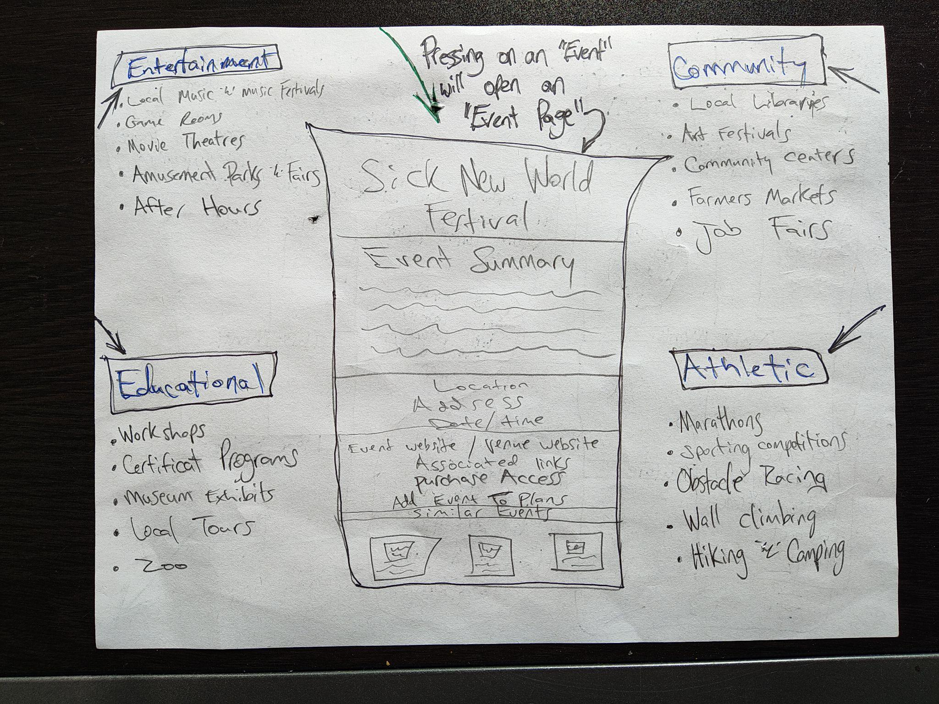

The app will host a multitude of functionalities, including Radio Buttons, Text Views, images, edit text windows, HTML, and much more. The main page will need two radio buttons, two search bars, a text display window, four scrollable windows, images, and links to local events. String data will be provided to the app via user input when searching for events and HTML data will need to be injected into the “Event Summaries”. Location data will also be uploaded to the app from the user’s device.

Below is a finished sketch of the Home Page, the Menu, and the Settings page.

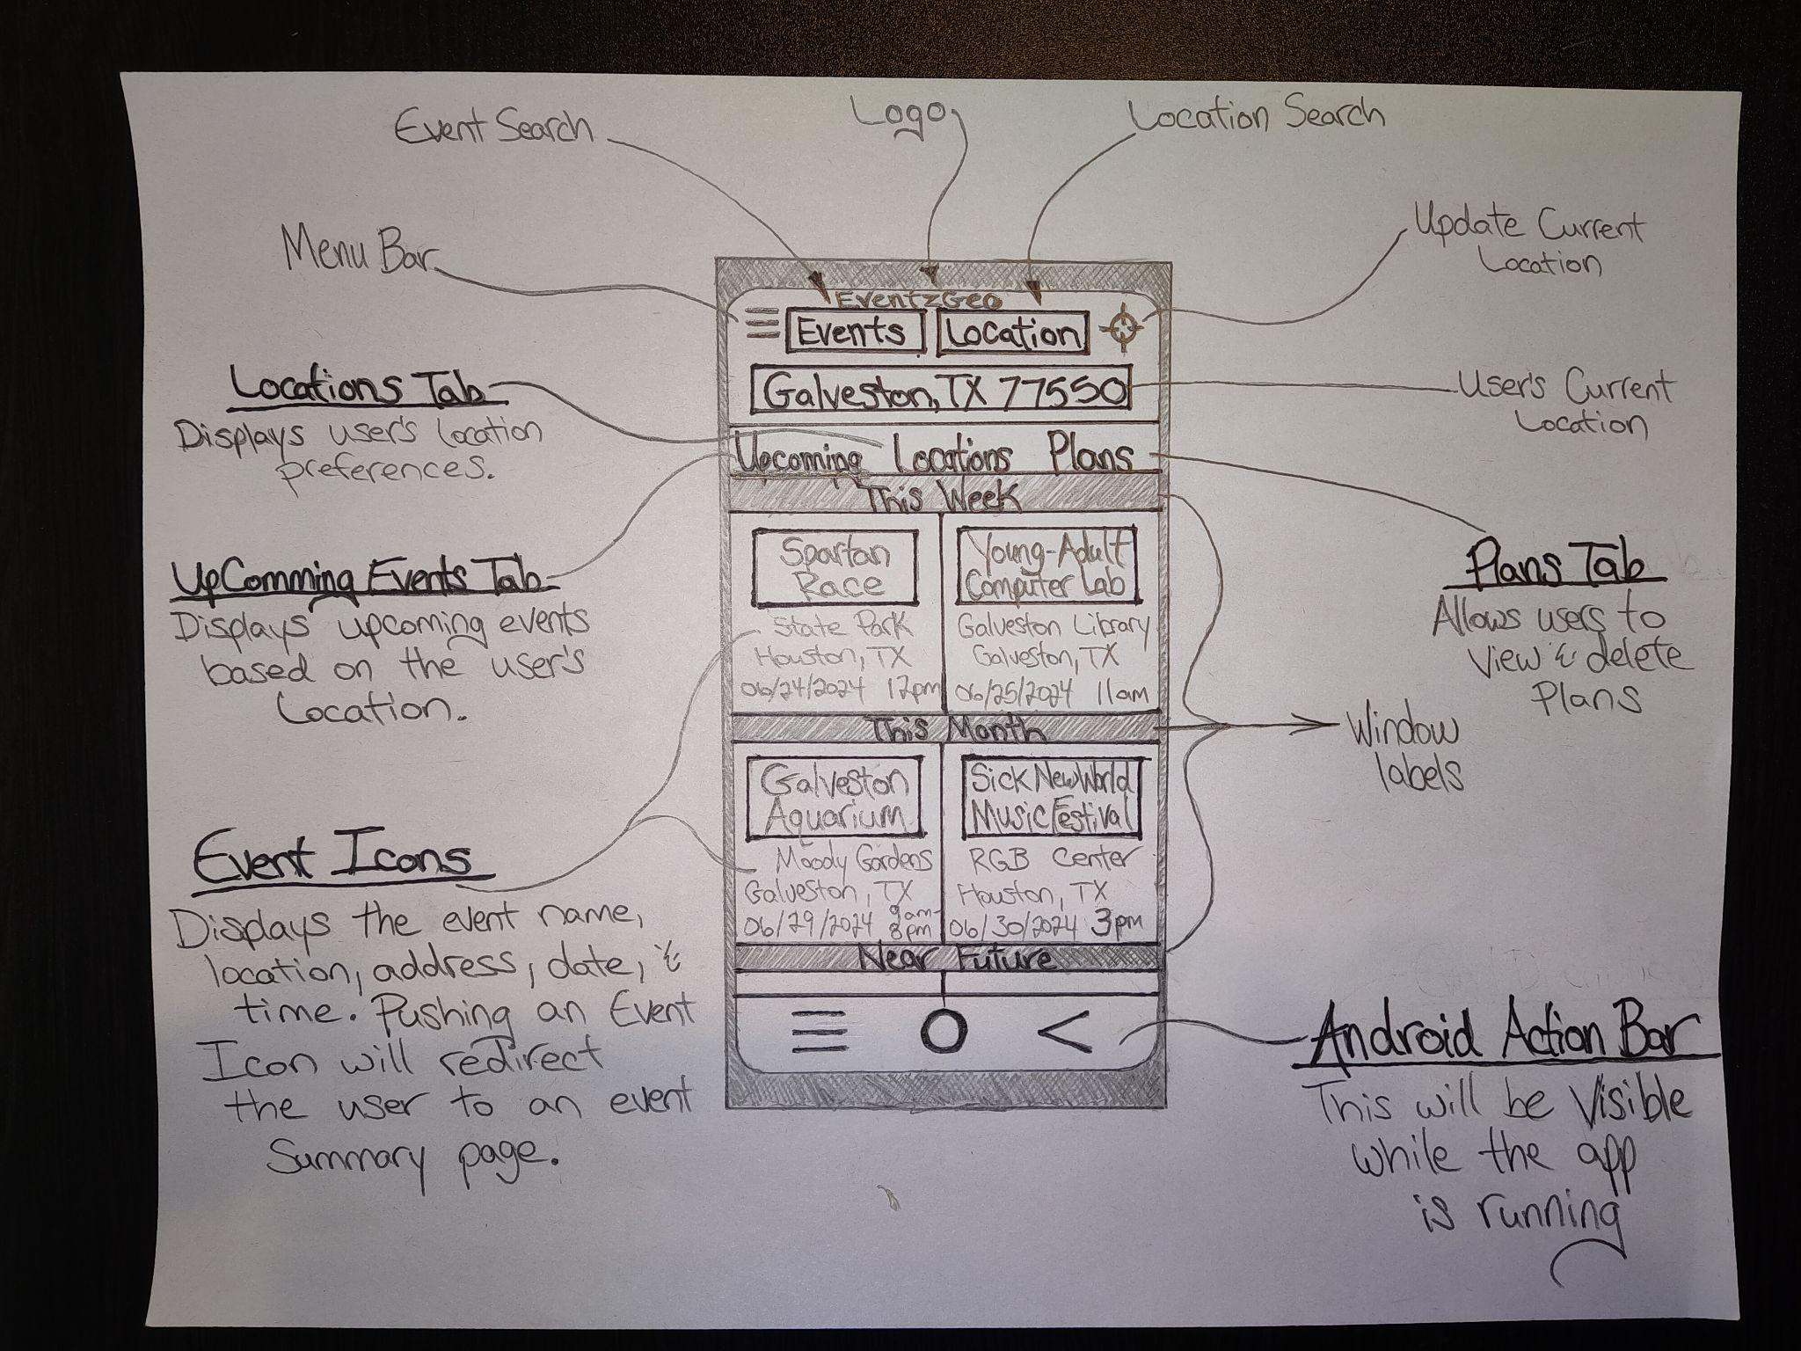

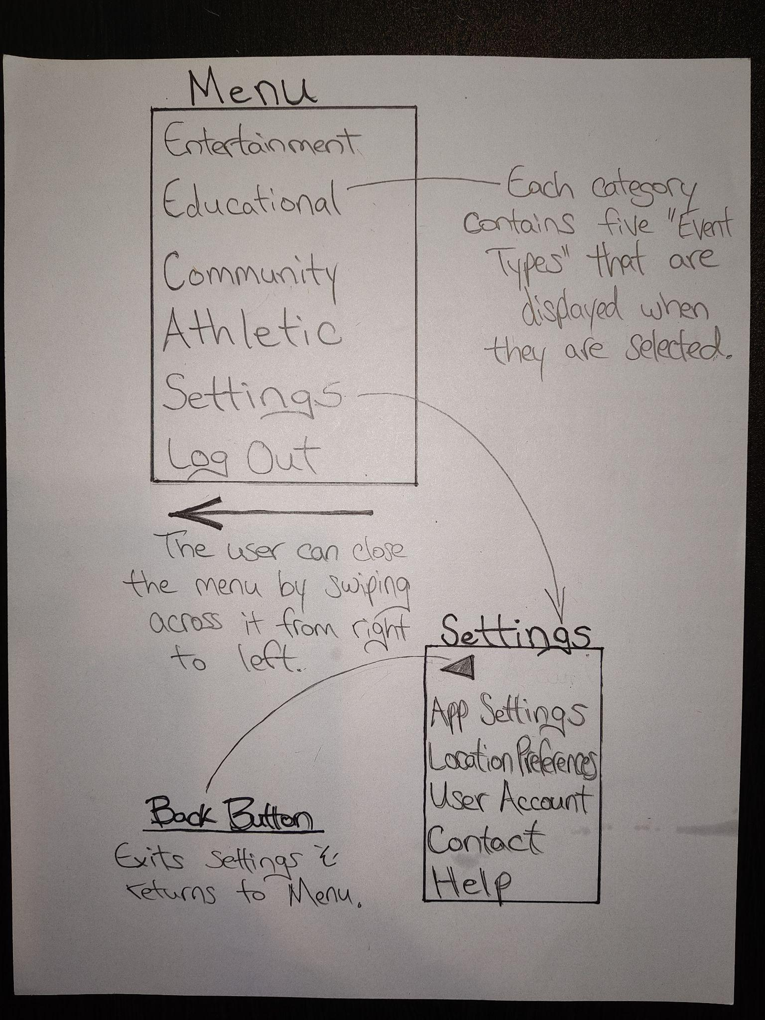

**Citations**

App Growth. (2023, February 13). How to Find Your Target Audience for Mobile Apps. App Radar.

https://appradar.com/blog/how-to-find-your-target-audience-for-mobile-apps

Play Console Help. (n.d.). Manage Target Audience and App Content Settings. Google.

https://support.google.com/googleplay/android-developer/answer/9867159?hl=en&visit_id=638508006513927718-2535684543&rd=1

Dam, R. F., & Siang, T. Y. (2024, February 24). Personas – A Simple Introduction. The Interaction Design Foundation.

https://www.interaction-design.org/literature/article/personas-why-and-how-you-should-use-them

Interaction Design Foundation - IxDF. (2021, June 14). What is Human-Centered Design (HCD)? Interaction Design Foundation - IxDF.

https://www.interaction-design.org/literature/topics/human-centered-design

Android Mobile App Developer Tools. Android Developers. (n.d.).

https://developer.android.com